Core Connections – Course 3 Name:_______________________
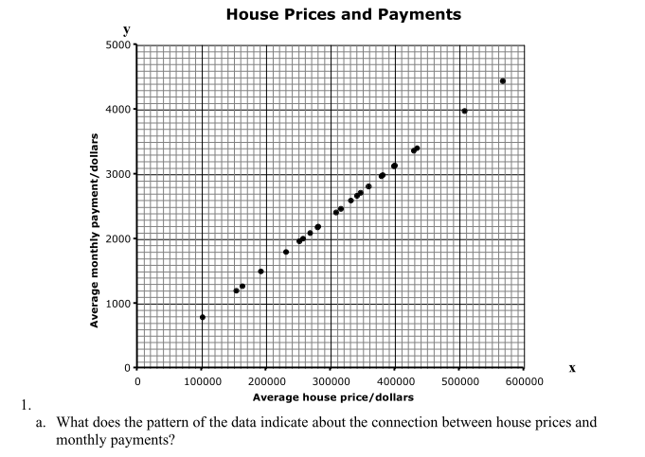
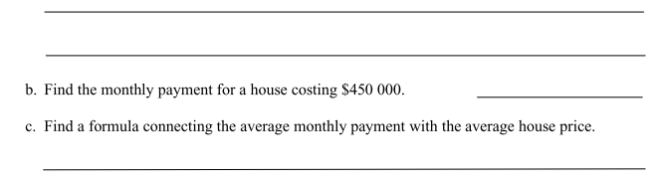
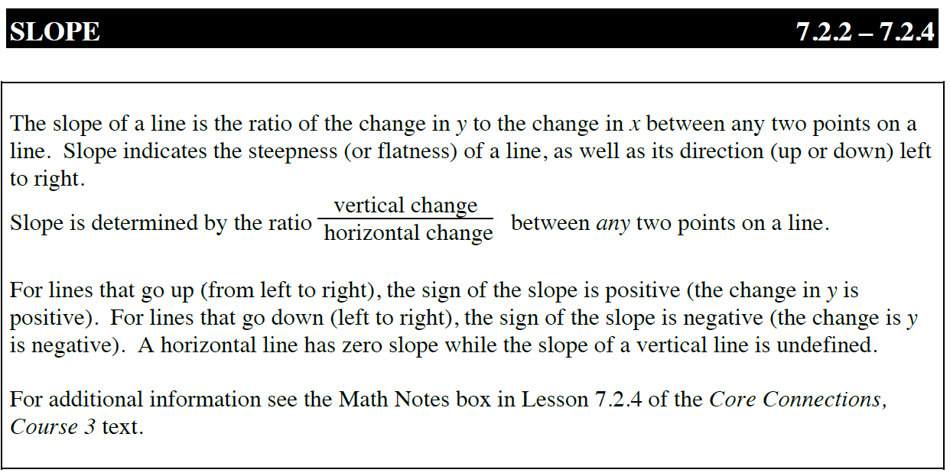
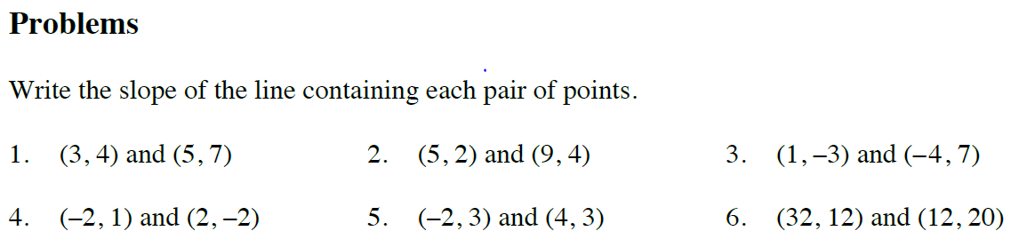

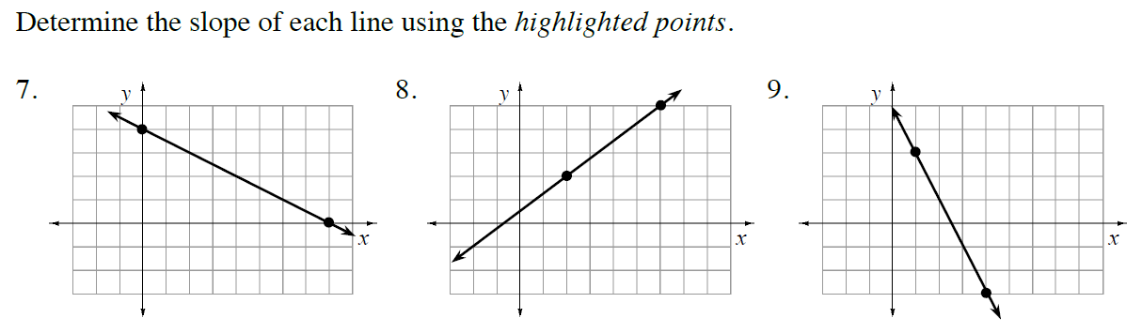
*Assume each axis is counting by ones.

