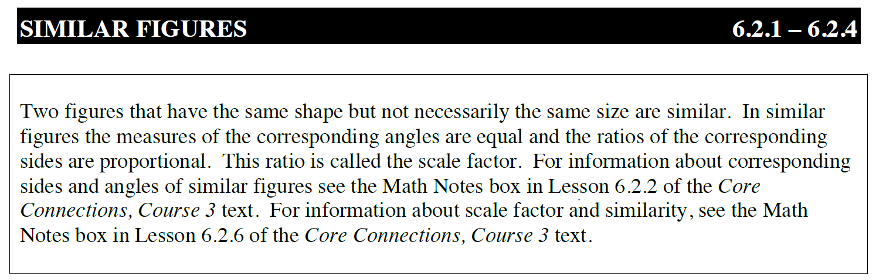
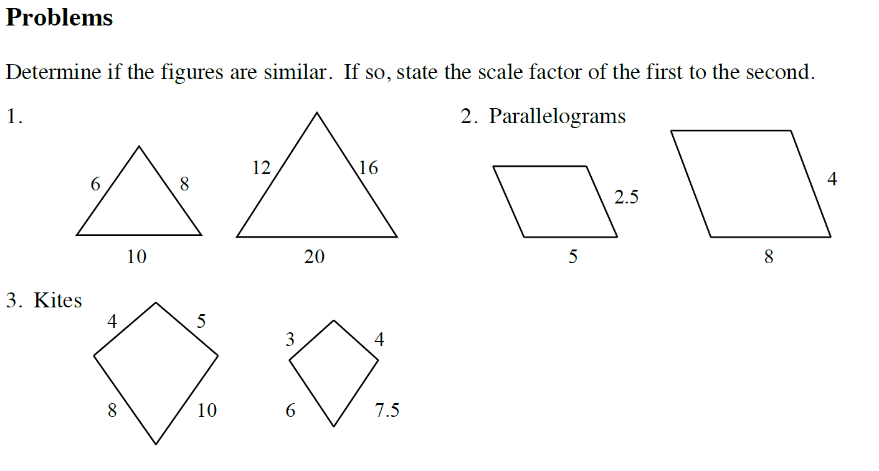
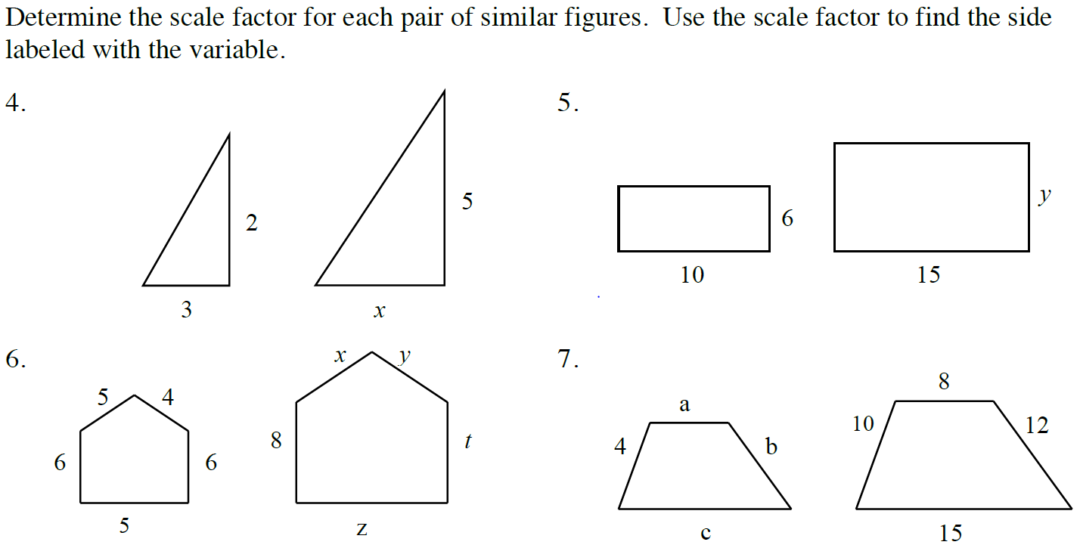
Dilation Problems
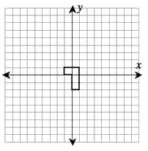
8. An L-shaped polygon is shown on the coordinate grid. Draw the dilation of this polygon after multiplying each coordinate by 1/2. List all of the coordinates of the new image after dilation.

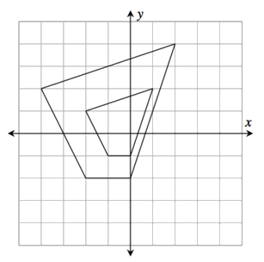
9. Avery graphed the larger quadrilateral and then created a dilation to give him the smaller quadrilateral. How would you describe this dilation? Be clear and complete.
Avery thinks his new quadrilateral is one-half the original. Is he correct? Explain completely.

