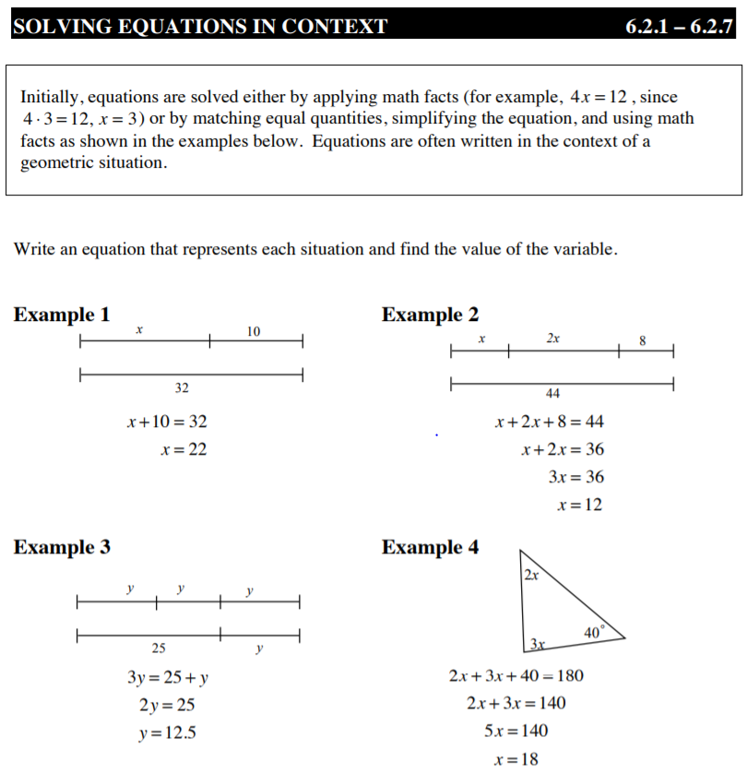
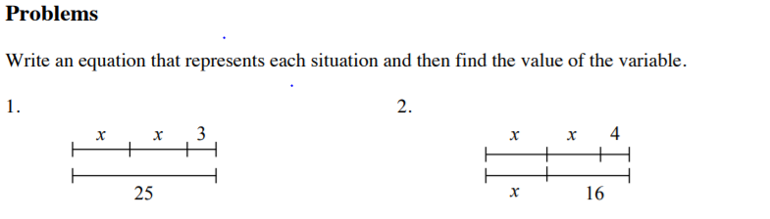
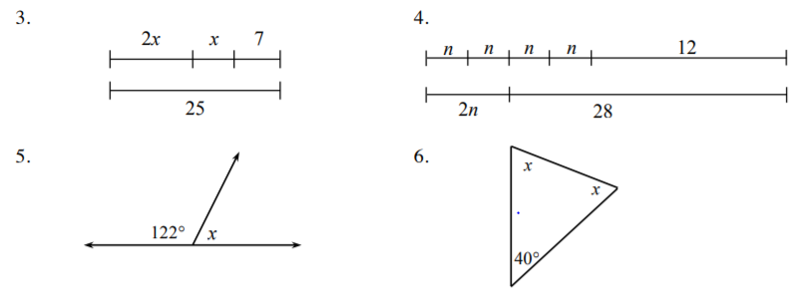

Use the 5D Process to solve each word problem.
7. Josephina is five years older than Cameron and the sum of their ages is 31. Can you write an equation and solve it to figure out their ages? Use the 5-D process to solve if you need to do so. How old are Josephina and Cameron? Show that your answer is correct.

8. Marta’s jump rope is 25 inches shorter than one and half times the length of Dilbert’s rope. If both their ropes laid together end to end measure 221 inches long, how long is Marta’s jump rope?

9. If one side of a square is increased by 12 feet and an adjacent side is decreased by three feet, a rectangle is formed whose perimeter is 64 feet. What is the length of the side of the original square?

10. Christina weighs 17 pounds more than twice her younger sister Sarah’s weight. When both girls stood on a freight scale, the reading was 179 pounds. How much does Christina weigh?

