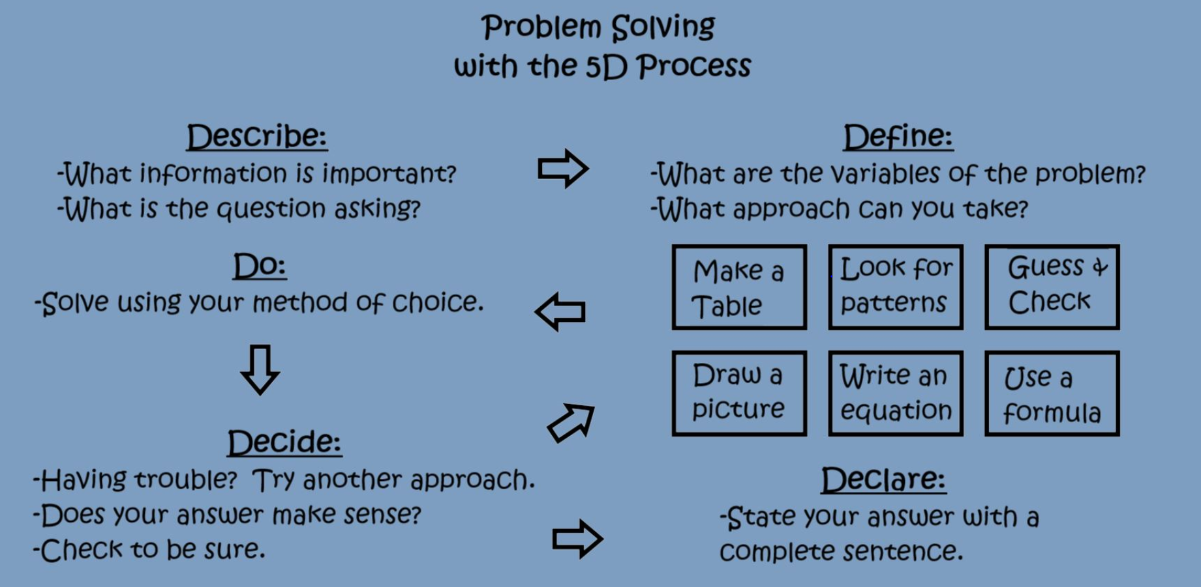
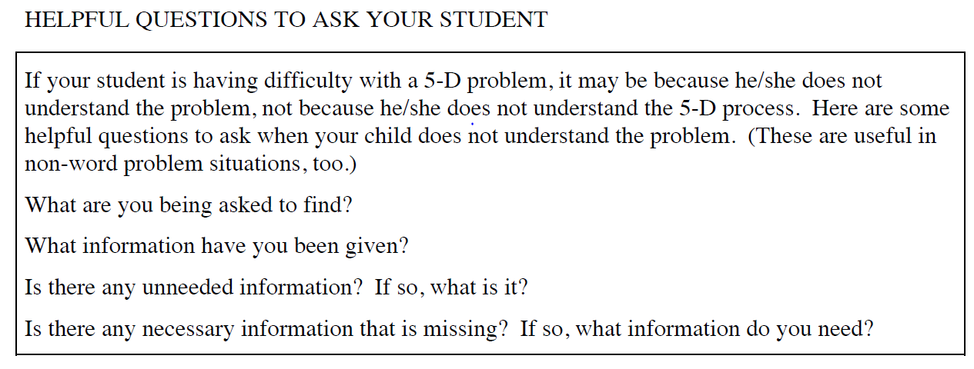
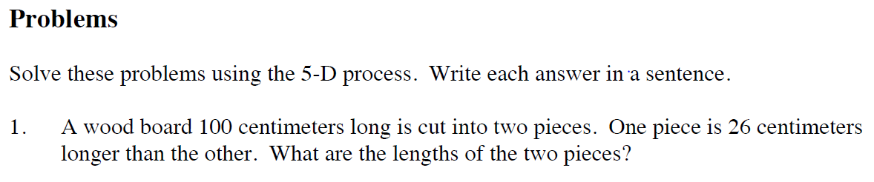
1st Piece (x) | 2nd Piece (x + 26) | 1st piece + 2nd piece | = 100?
20 | 46 | 20 + 46 | 66 (too low)

Declare Answer:__________________________________________

