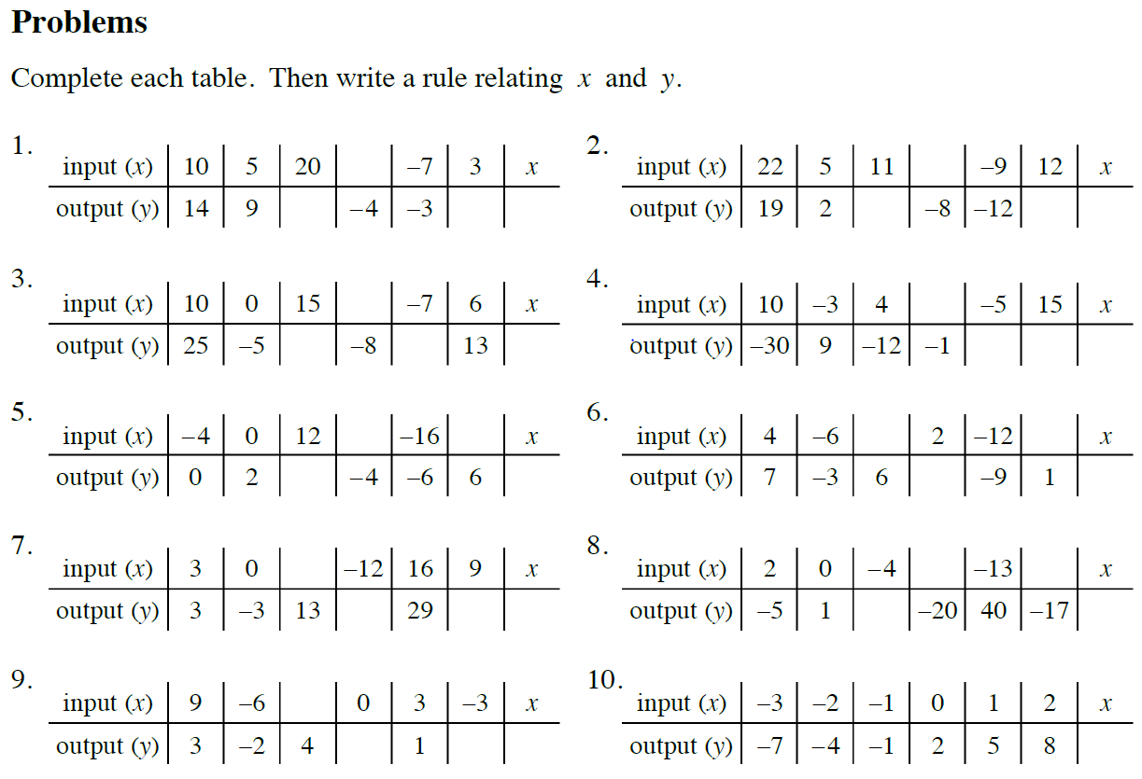
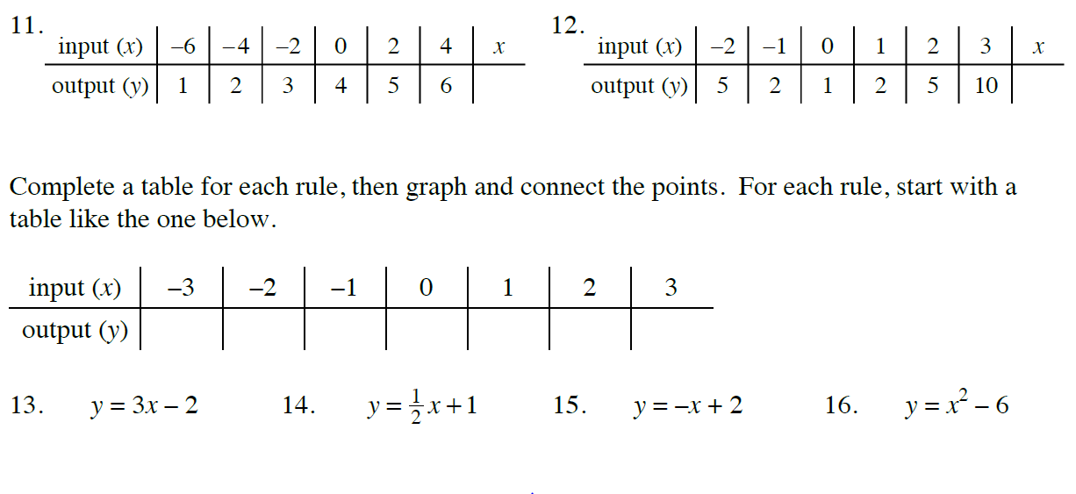

CC3 Tile Patterns
1. Look at the figures below. With your team, find as many ways as possible to describe how the tile pattern is growing. How many tiles would be in the 100th figure? Find as many ways as you can to justify your conclusion.
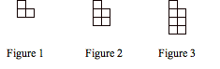
2. Determine the rule for the pattern below.
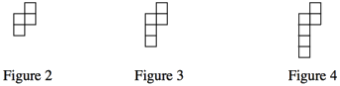

3. Examine this tile pattern and answer the questions below.
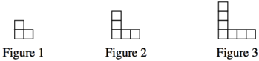
a. Write a rule that describes this pattern.
b. Which figure number has 41 squares? Show or explain how you figured it out.
4. Examine this tile pattern and answer the questions below.
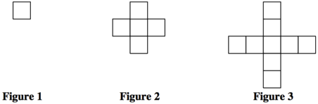
a. Draw figures 4 and 5 on your paper.
b. Describe how the pattern grows and any other patterns you notice.
Bonus: How many squares would figure 100 have? Explain how you know.

